Software Project Management Plan

for

Learning Management System

**Prepared by:**

**Luis Llanas**

**Rafael Navarro**

**Diana Rodarte**

**Eva Ruiz**

**Software Engineering CS3321**

**August 29, 2019**

Table of Contents

1.0 Introduction 3

1.1 Project Overview 3

1.2 Project Deliverables 3

1.3 Evolution of the SPMP 3

1.4 Reference Materials 3

1.5 Definitions and Acronyms 3

2.0 Project Organization 4

2.1 Process Model 4

2.2 Organizational Structure 4

2.3 Organizational Interfaces 4

2.4 Project Responsibilities 4

3.0 Managerial Process 5

3.1 Management Objectives and Priorities 5

3.2 Assumptions, Dependencies, and Constraints 5

3.3 Risk Management 5

3.4 Monitoring and Controlling Mechanisms 5

3.5 Staffing Approach 5

4.0 Technical Process 6

4.1 Methods, Tools, and Techniques 6

4.2 Software Documentation 6

4.2.1 Software Requirements Specification (SRS) 6

4.2.2 Software Design Description (SDD) 6

4.2.3 Software Test Plan 6

4.3 User Documentation 6

4.4 Project Support Functions 6

5.0 Work Packages, Schedule, and Budget 7

5.1 Work Packages 7

5.2 Dependencies 7

5.3 Resource Requirements 7

5.4 Budget and Resource Allocation 7

5.5 Schedule 7

6.0 Additional Components 8

6.1 Index 8

6.2 Appendices 8

1. **Introduction**

* 1. **Project Overview**

This document has the purpose of describing all the technical aspects concerning the development of a Learning Management System for the Software Engineering class at the University of Houston Downtown. All the content is directed to the members of the group for planning and scheduling purposes, serving as a summary document about the evolution of the project and member’s activities.

* 1. **Project Deliverables**

The project will develop an LMS software which will have three different kind of users: professors, students, and administrators. The system will allow professors to include theirs classes, manage their content, include exam questions and answers, and track student’s progress. The students will be able to view an exam, submit answers to the questions on the exam, and be able to keep track of their grades. The administrator will be able to manage all aspects of the system.

* 1. **Evolution of the SPMP**

The software development utilizes the GitHub version control system available online. Proposed changes and new versions will be available on GitHub, and this document was properly updated.

* 1. **Reference Materials**

No reference codes were used in the development of the Learning Management System. All code was done by individual developers and previous knowledge of Python language. The Graphical User Interface design was generated by the PyQt Creator.

* 1. **Definitions and Acronyms**

LMS – Learning Management System

GUI – Graphics User Interface

UML - Unified Modeling Language

UI – User Interface

1. **Project Organization**
   1. **Process Model**

The project initiated on August 26th, 2019 and with the team using Django to develop the Learning Management System. However, after careful taught and consideration, it was confirmed to transition to a different platform due to short amount of time to implant. We decided to switch to using PyQt Designer

The project uses an object-oriented design methodology and it is based on the Democratic Life-Cycle model. At this initial phase, each member of the team has one activity that has to be submitted to the platform GitHub. Later on, the members will interact with each other and produce the software prototype utilizing the GitHub as a version control tool.

* 1. **Organizational Structure**

The client:

Dr. Yuchou Chang.

The Project managers is:

Rafael Navaro

The infrastructure team consists of:

Luis Llanas, Eva Ruiz

The Software Project Management Planning (documentation) is:

Diana Rodarte

* 1. **Organizational Interfaces**

Meetings times:

09/04/2019 – 2:30PM till 4:00PM

09/11/2019 – 2:30PM till 4:00PM

09/18/2019 – 2:30PM till 4:00PM

11/13/2019 – 2:30PM till 4:00PM

11/16/2019 – 1:00PM till 5:00PM

11/25/2019 – 12:45PM till 3:00PM

* 1. **Project Responsibilities**

Diana Rodarte: UML, Software Development, and documentation.

Eva Ruiz: Software Development, and documentation.

Luis Llanas: GUI, Software Development, and documentation.

Rafael Navarro: Software Development, and documentation.

1. **Managerial Process**
   1. **User Interfaces**

Figure 1, demonstrates the GUI for the Login app screen where the user can select the checkbox if they are a “Student” or “Professor”. Then if they would like to create an account, they can click the “Signup” button, after they entered the desired username and password. Once the user creates their credentials then they may click the “Login” button. If the user already had an account initially, they may just enter their username and password and click the “Login” button. If the user desires to not “Login” or “Signup” they may quit the interface by clicking the “Quit” button.

All buttons have a black border and a font of Arial. This user interface will not support a 4k screen resolution but anything under it will.

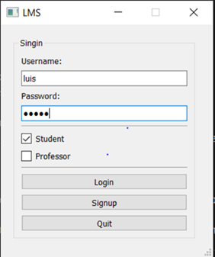

Figure 1. Login app screen

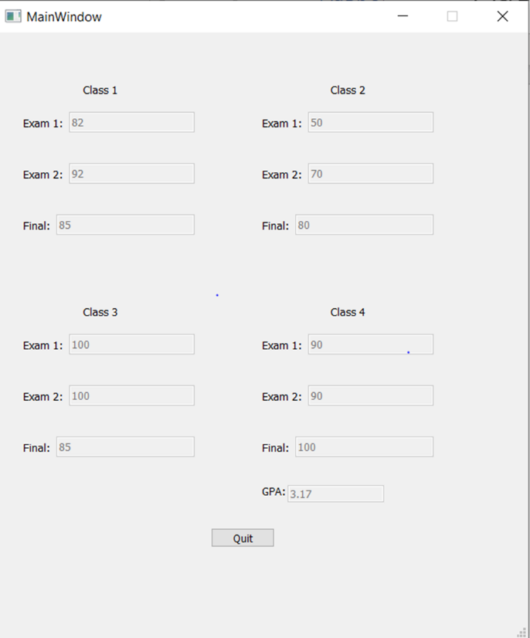

* 1. **Management Objectives and Priorities**

The initial objective is to define all entities and its attributes. It will help the project team to develop the objects (classes) and prepare a database. This is set as a high priority since this is a necessary information, understand the data flow, in order to proceed with further steps.

* 1. **Assumptions, Dependencies, and Constraints**

In progress.

* 1. **Risk Management**

Since the project is being developed for a class project, there is no risk involved.

* 1. **Monitoring and Controlling Mechanisms**

In progress.

* 1. **Staffing Approach**

In progress.

1. **Technical Process**
   1. **Methods, Tools, and Techniques**

The project was developed using PyQt Designer to create the graphical UL’s more efficient from the Qt GUI framework. It allowed for a simple drag and drop interface for laying out components such as buttons, text fields, combo boxes and more.

* 1. **Software Documentation**

In progress.

* + 1. **Software Requirements Specification (SRS)**

The software being developed is a Learning Management System. Thus, this system should allow faculty to create their classes/courses, include its content, include the assignments, and track students’ progress. From students’ perspective, the system should allow them to visualize the classes’ content, submit their assignments, and follow their grades posted.

* + 1. **Software Design Description (SDD)**

In progress.

* + 1. **Software Test Plan**

The software testing plan used was unit testing. Where the teams

* 1. **User Documentation**
  2. **Project Support Functions**

In progress.

1. **Work Packages, Schedule, and Budget**
   1. **Work Packages**
   2. **Dependencies**

In progress.

* 1. **Resource Requirements**

In progress.

* 1. **Budget and Resource Allocation**

Since this project is being developed in a form of class project, there is no budget.

* 1. **Schedule**

In progress.

1. **Additional Components**
   1. **Index**
   2. **Appendices**